**Getting objects**

**There is DOM methods used to get html element and return it as an object.**

|  |  |
| --- | --- |
| Methods of Finding HTML objects | |
| **Methods** | **Description** |
| **document.getElementById(“id”)** | Get an element by **id.** |
| **document.getElementsByTagName(“ objectName ”)** | Get elements by **tag name.** |
| **document.getElementsByClassName(“name”)** | Get elements by **class name.** |
| **document.querySelectorAll("selector");** | Get elements by **CSS selector** (id, class names, types, attributes, values of attributes, etc.) |
| **Document.querySelector(“Selector”)** | Get element by its **CSS selector** (id, class names, types, attributes, values of attributes, etc.) |
| **document.forms["form id"]** | Get form element by its **id.** |

**Notes: Unknown** will return if the founded element wasn’t presence in Html or Html5 list. (عنصر من اختراعك).

1. **document.getElementById(“id”)**

This method is used to get element through its **id** and return it as an object. In case of absence this “id”, **null** returns.

**Note:** this method use to get single element as it use “id” which is a unique selector in whole document object.

**Example:**

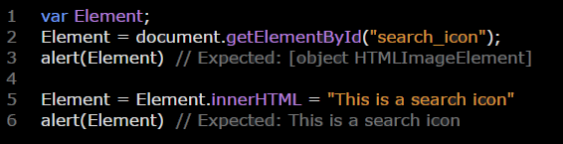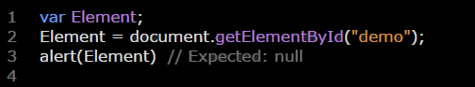

1. **document.getElementsByTagName(“objectName”)**

This method is used to get element**s** by its tag name; In case of absence this “id”, **undefined** returns.

**Note:** this method use to get more than one element (HTML collection) as it use “tag” selector which isn’t unique selector. So we need to use **[ ]** to specify the selector we need.

**Example:**

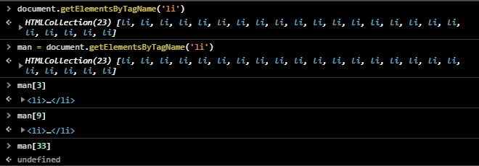

1. **document.getElementsByclass(“className”)**

This method is used to get element**s** by its class name; In case of absence this “class”, **undefined** returns.

**Note:** this method use to get more than one element (HTML collection) as it use “class” selector which isn’t unique selector. So we need to use **[ ]** to specify the selector we need.

**Example:**

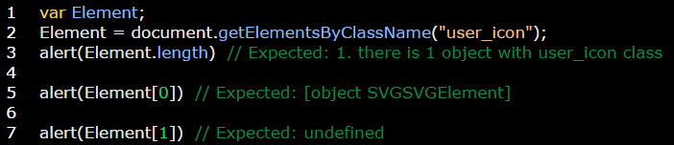

1. **document.querySelectorAll(“Selector”)**

This method is used to get element**s** by its selector; In case of absence this “selector”, **undefined** returns.

**Note:** If the selector is “**class or tag name**” we use **[ ]** to specify specific element from the returned (HTML collection).

**Example:**

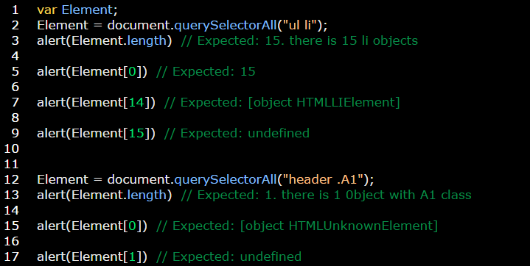

1. **document.querySelector (“Selector”)**

This method is used to get the first element has used selector; In case of absence this “selector”, **null** returns.

**Note:** If the selector is “**class or tag name**” we use **[ ]** to specify specific element from the returned (Node list).

**Example:**

